**HOME APPRAISALS DISPARITY ANALYSIS (JUNE 2022)**

**DATASETS:**

Enterprise Public Use Databases, [Single-Family Properties Census Tract File (2018-2020)](https://www.fhfa.gov/DataTools/Downloads/Pages/Public-Use-Databases.aspx), Federal Housing Finance Agency; [U.S. Census American Community Survey](https://data.census.gov/cedsci/) (5-year averages), 2019, U.S. Census Bureau.

**METHODOLOGY/NOTES:**

We used nationwide home loan originations data collected by the Federal Housing Finance Agency (FHFA) to measure disparities in “appraised values” vs. “contract” or sales prices for homes sold and refinanced between 2018 and 2020, based on the racial makeup of census tract neighborhoods, and homebuyers.

While FHFA has archived loan originations data dating back to 2010, we used data from the most recent three-year period because they contained elements needed for calculations that are not in data from earlier years.

In the appraisal process, an independent real-estate appraiser determines a home’s value by usually looking at: (1) the basic condition of the home for sale; (2) any upgrades or improvement to the home made by the seller, and (3) what similar homes in the area have recently sold for, and how local property values are trending.

While lenders require an appraisal as a condition of loan closing, the buyers typically pay for the evaluation -- unless they negotiate for the seller to pay instead. The cost might range from $300 to $600, depending on the size and location of the home, and the amount of research done by the appraiser.

Depending on the lender and circumstances, alternative appraisals may be requested to reduce costs and speed up the process. They include: (1) Hybrid appraisals, where appraisers never physically visit the home, but use photographs from a home inspection, or hire someone to gather site-specific information; (2) Desktop appraisals, where appraisers use online information – property records, floor plans, comparable sales listings, etc., and (3) Drive-by appraisals, where appraisers do exterior-only evaluations.

Any process that is used gives the appraiser a great deal of latitude to determine a fair market value for a property – one of the biggest factors in buying or refinancing a home.

In a sales transaction, homes appraised lower than the selling price can mean bad news for both the buyer and seller.

Typically, when an appraisal comes in low, a mortgage lender will not lend more than the appraised value. That means the buyer has to pay more out of pocket, or convince the seller to lower the asking price, to buy the house.

Under-appraising homes during a sale can either drive away buyers who are unable or not inclined to increase the down payment, or drive down home values in certain neighborhoods.

Under-appraising during refinancing can also create problems for the homeowner. If the appraised value is too low, then typically you can’t refinance.

If the appraisal value puts the home equity at less than 20%, then homeowners may get stuck paying for private mortgage insurance, or having to bring cash to the closing table to do a “cash-in” refinance.

For our ABC-OTV analysis, we first filtered the datasets to include only single-family, one-unit homes that were either “purchased” or refinanced through mortgage loans during the three-year period.

We then calculated each buyer’s “down payment,” or the amount invested in the home beyond the mortgage loan to meet the selling price, by multiplying the home’s Loan-To-Value” ratio (LTV) by the loan amount.

We added the “down payment” to the mortgage loan to get an estimated “contract,” or sales price of the home.

Then, we compared the sales price to the “property value” of each home – [a proxy for the appraised value, according to FHFA](https://www.consumerfinance.gov/rules-policy/regulations/1003/4/#a-28).

Based on the calculations, we used our data to tally the number of homes sold in census tracts over the three-year period where the appraisal was HIGHER or LOWER, overall, than our calculated contract price in a sales origination.

We did a separate comparative tally for refinanced home loans over the period.

We also calculated whether the appraisal was 2% or more below the sales price – a threshold [used in Fannie Mae studies](https://www.aei.org/wp-content/uploads/2017/08/Fout-Panel-VI.pdf) to measure the most severe “Appraisals Below Contract” (ABCs).

Then, we used 2019 census demographic data to develop population, racial makeup, income and other characteristics of each tract.

Our analysis focuses on who benefits from an [appraisal process that studies show, over time, has been subjective and biased](chrome-extension://efaidnbmnnnibpcajpcglclefindmkaj/viewer.html?pdfurl=https%3A%2F%2Fwww.fhfa.gov%2FPolicyProgramsResearch%2FResearch%2FPaperDocuments%2FAVM_revised_final.pdf&clen=726648&chunk=true).

The summarized data replicate a [September 2021 study](https://www.freddiemac.com/research/insight/20210920-home-appraisals) by The Federal Home Loan Mortgage Corporation (Freddie Mac), which used six years’ worth of actual appraisal data from its own proprietary data source to examine racial and ethnic valuation “gaps” in home purchase appraisals.

The Freddie Mac study looked at differences in appraisals or selling prices of homes sold in census tracts that were majority Black (50% - 100%); majority Latino (50% - 100%); majority White (50% - 100%), and other minority (not majority White).

It also looked at under-appraisal of homes by race / ethnicity of the buyer: Asian; Black; Hawaiian/Pacific Islander; Hispanic/Latino; Native American; Unknown, and White.

***NOTE:*** *The disparity patterns we found in our three-year analysis using the FHFA data were consistent with the Freddie Mac study, which used a different data source over a longer period of time.*

**FINDINGS:**

An [October 2017 Fannie Mae study](https://www.aei.org/wp-content/uploads/2017/08/Fout-Panel-VI.pdf) of appraised home values concludes that **appraisals come in below contract price about 8% of the time**.

But our analysis shows the portion of “ABC” home sales vary greatly when considering the racial composition of the neighborhood and the race/ethnicity of the buyer.

* **Appraisers were more likely to value homes below their contract price in census tract neighborhoods where the residents are mostly Black or Latino**. Overall, the data show that homes sold in neighborhoods with 50% or more Black residents are **2.5x** more likely to be under-appraised by 2% or higher than homes sold in mostly White neighborhoods (neighborhoods where any minority resident share is below 50%). Home mortgages refinanced in mostly Black neighborhoods are **3.5x** more likely to be under-appraised by the 2% or higher than in mostly White neighborhoods. For home sales in neighborhoods with 80% or more Black residents, the 2%+ under-appraised rate jumps to **2.75x** higher in Black neighborhoods than in mostly White neighborhoods. For refi loans in the 80% or more Black neighborhoods, the rate is **4.7x** higher than in mostly White neighborhoods. (*See chart below for sale appraisal disparities in mostly Black, Latino and White neighborhoods).*

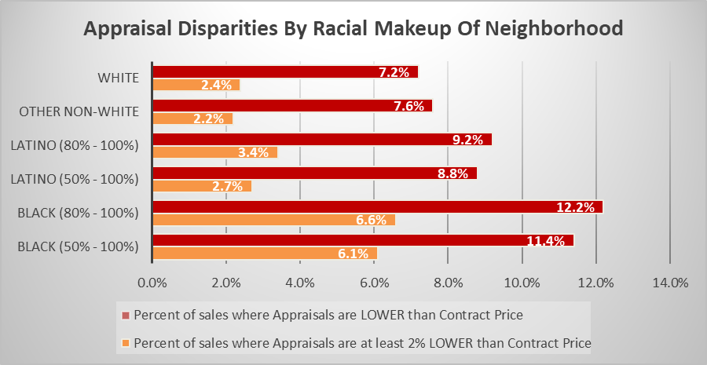

* **Appraisers were more likely to under-value homes in poorer neighborhoods – particularly poorer neighborhoods that are mostly Black or Latino – than in wealthier mostly White neighborhoods.** Overall, home sales where appraisals fell at least 2% below the selling price were **9x** more likely in tract neighborhoods with median household income of $35,000 or less than in neighborhoods with income of more than $75,000. Refi mortgages were **24x** more likely to be under-appraised by 2% or more in the lowest-income neighborhoods than in the wealthiest. In the nation’s poorest mostly-Black or Latino neighborhoods, the 2% or higher under-appraised sales rate is **6x-9x** higher than in the wealthiest mostly White neighborhoods, and the refi rate is **10x-30x** higher. (See *charts below for sale appraisal disparities in the poorest and wealthiest neighborhoods*).

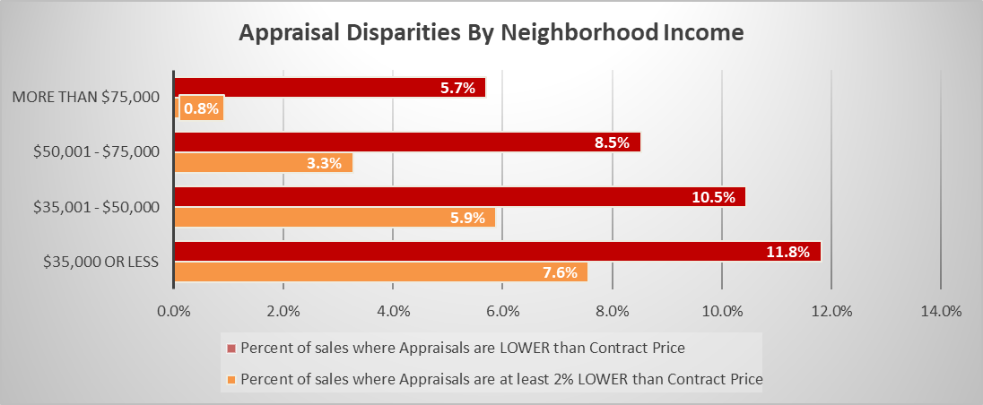

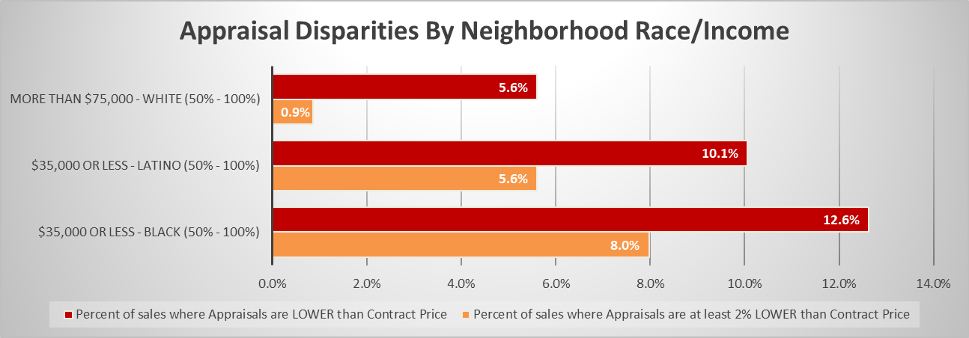

* **Black and Latino buyers were more likely to have purchased a home that was under-appraised than White buyers.**  The data indicate the percent of severely under-appraised homes (at least 2% below contract price) being sold to Black buyers, or refinanced by Black homeowners, is nearly **twice as high** as it is for White homebuyers. That means that, during the three-year analysis period, thousands of Black homebuyers likely had to pay larger-than-expected down payments, higher interest rates on mortgages, and pay for private mortgage insurance. (*See chart below for sales appraisal disparities for homebuyers of different race / ethnicity*).

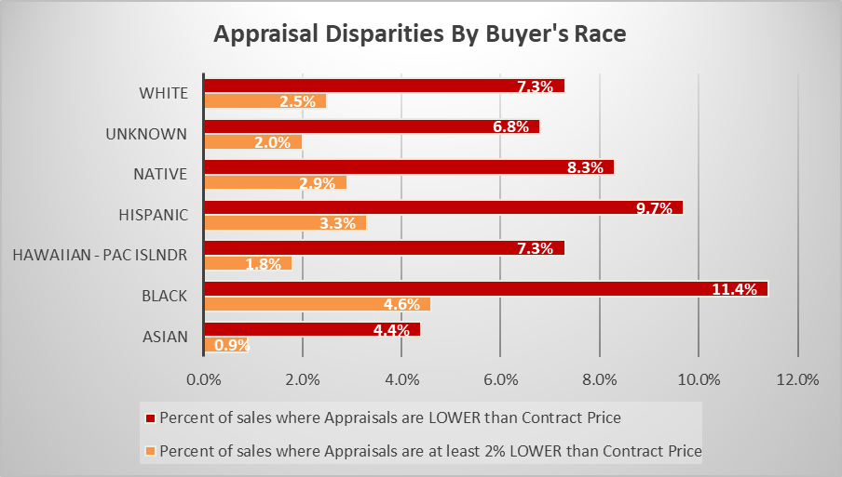

* **Black and Latino buyers were more likely than White buyers to have purchased an under-appraised home, whatever the racial makeup of the neighborhood.** In mostly Black neighborhoods, the rate of homes under-appraised by 2% or more that were sold to Black homebuyers was **1.4x** higher, and the refi rate for Black homeowners was **2.4x** higher, than for Whites buying or refinancing in the same neighborhoods. In mostly Latino neighborhoods, the 2%+ under-appraised rate for Latino buyers was nearly **1.3x** higher than for Whites buying in those neighborhoods. The 2%+ under-appraised refi rate for Hispanic homeowners was **2.7x** higher than for White homeowners in mostly Hispanic neighborhoods. For Black and Latinos buying homes in mostly White neighborhoods, severely under-appraised rates were **1.5x** and **1.2x** greater than for White homebuyers. (*See chart below for sales appraisal disparities for homebuyers of different race / ethnicity in mostly Black, Hispanic and White neighborhoods*).

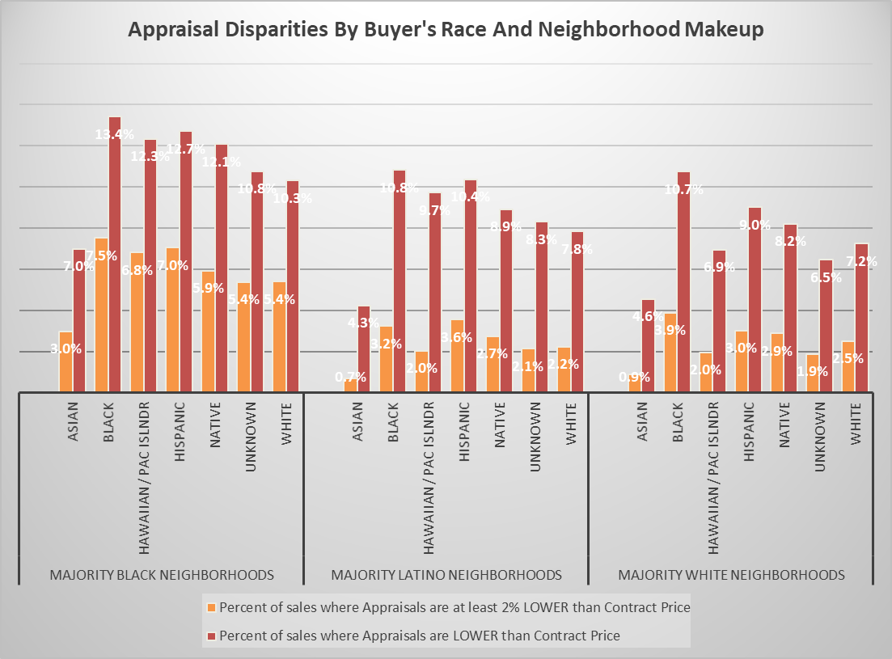

* **Midwest states have the highest rate of under-appraised and severely under-appraised home sales in the U.S**. In the dozen states that make up the Midwest Region of the nation (IA, IL, IN, KS, MI, MN, MO, ND, NE, OH, SD, and WI) one in every 10 homes sold was under-appraised, and one in 20 was under-appraised by 2% or higher between 2018 and 2020. In majority-Black Midwest neighborhoods, overall under-appraised home sales are at 16% -- twice the national rate – and 2%+ under-appraised homes are at **5x** the national average. For refi mortgages under-appraised by 2% or more, the Midwest rate was tops among the four U.S. regions (Midwest, Northeast, South, West), and **2.4x** higher than the national average. The regional disparity plays out with individual states – the top six states (IA, OH, IN, KS, MI and NE) are all in the Midwest. All have double-digit rates of overall under-appraised sales, and homes with appraisals 2% or greater than the selling price are all at least twice the national rate. Iowa, in particular, has a [long history of appraisal complaints](https://www.idob.state.ia.us/reap/) – at least 160 have been filed since 2009, and many of them involve under-appraising properties. (*See chart / map below for sale appraisal disparities for Regions and States*).

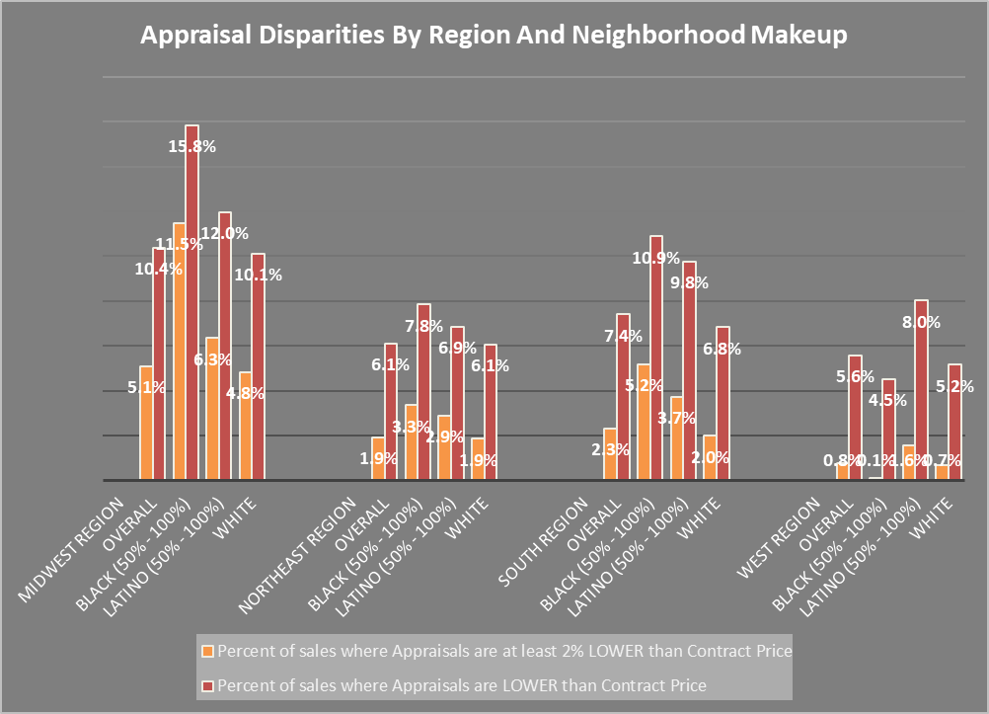

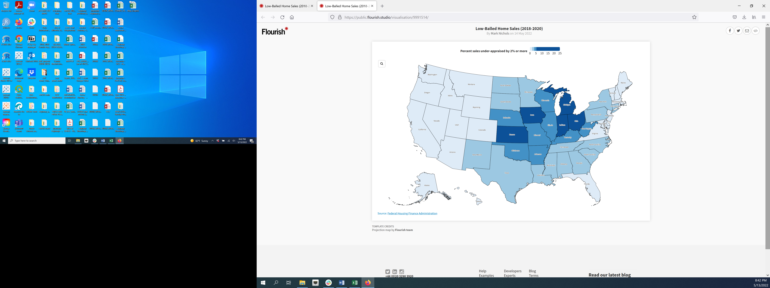

* **In the primary counties of our OTV stations, there are startling disparities in overall under-appraised home sales and refi rates in mostly Black or Latino neighborhoods compared to mostly White neighborhoods**. In Fresno, Los Angeles and Alameda counties, CA, and Philadelphia County, PA, the overall under-appraised rate per 1,000 homes in mostly Latino neighborhoods were highest during the three-year analysis period -- **1.5x to 4x** higher than in mostly White neighborhoods. Refi rates in Latino neighborhoods were **at least twice as high** as in White neighborhoods in Alameda, Fresno and Los Angeles counties in California and Philadelphia County, PA. In Cook County, IL; Harris County, TX , Wake County, NC and Bronx County, NY, ratesper 1,000 were highest in mostly Black neighborhoods, and **1.5x-2.5x** higher than in mostly White neighborhoods. Refi rates in mostly Black neighborhoods were **at least twice as high** as in mostly White neighborhoods in Alameda County, CA; Harris County, TX; Cook County, IL; Philadelphia County, PA, and Wake County, NC. *(See charts below for sale appraisal disparities in OTV counties).*



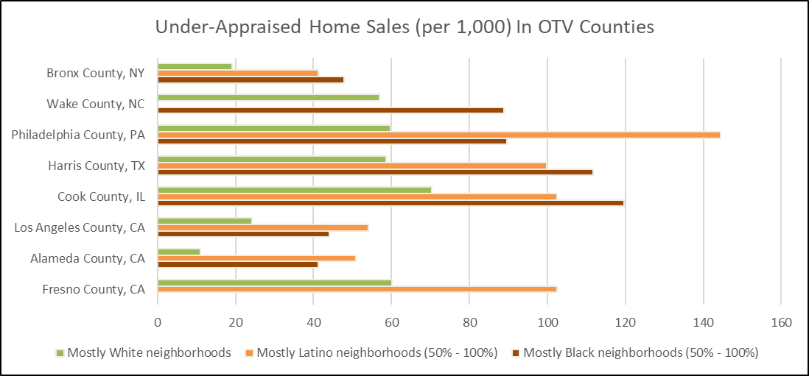

*--- Mark Nichols*